**Popeyes Management App**

IS 436-03 Structured Systems Analysis and Design Project

Deliverable 5: “Closing: User Interface Design, Program design and System

Implementation

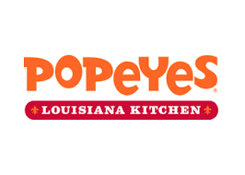

Group Members:

Jessica Park

Farah Siddiqui

Betelhem Taddele

Danny Nguyen

Jatin Chauhan

Munam Ghazanfar

Ninh Ngo

Adil Mufti

05/09/2019

**Table of Contents**

User Interface Design……………………………………………………………………………. 2

Homepage Prototype …………………………………………………………………… 2

Owner Page Prototype …………………………………………………………………. 2

Manager Page Prototype ………………………………………………………………. 3

Interface Standards …………………………………………………………………….. 3

Program Design …………………………………………………………………………………. 4

System Requirements ..………………………………………………………………………… 6

Team Experiences ………………………………………………………………………………. 7

Updated Project Plan …………………………………………………………………………… 9

Gantt Chart ………………………………………………………………………………………. 10

**User Interface Design**

Login page:

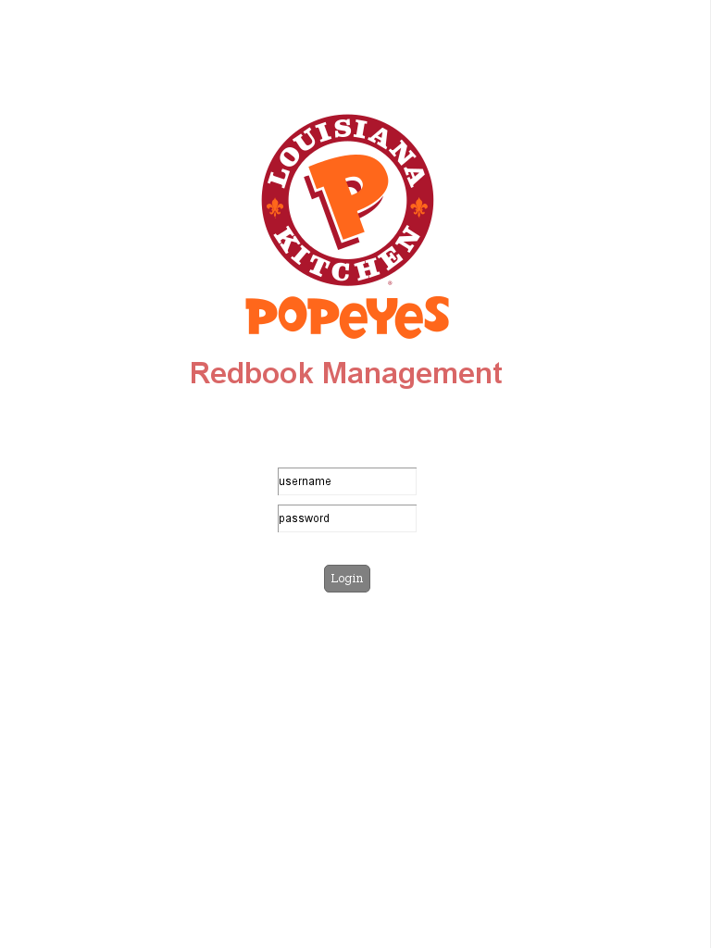

Owner Page:

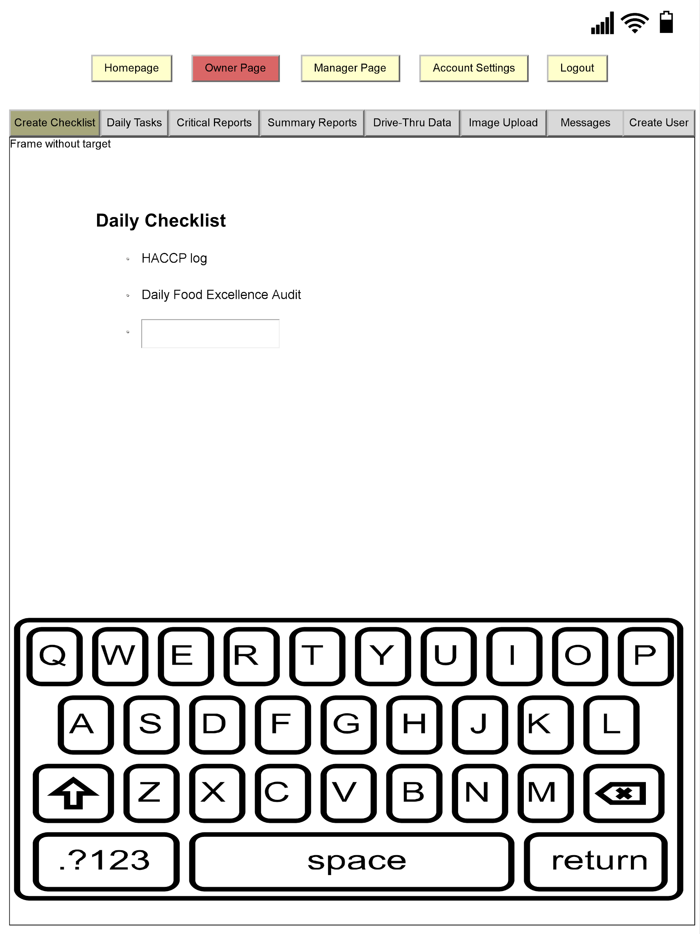

Manager Page:

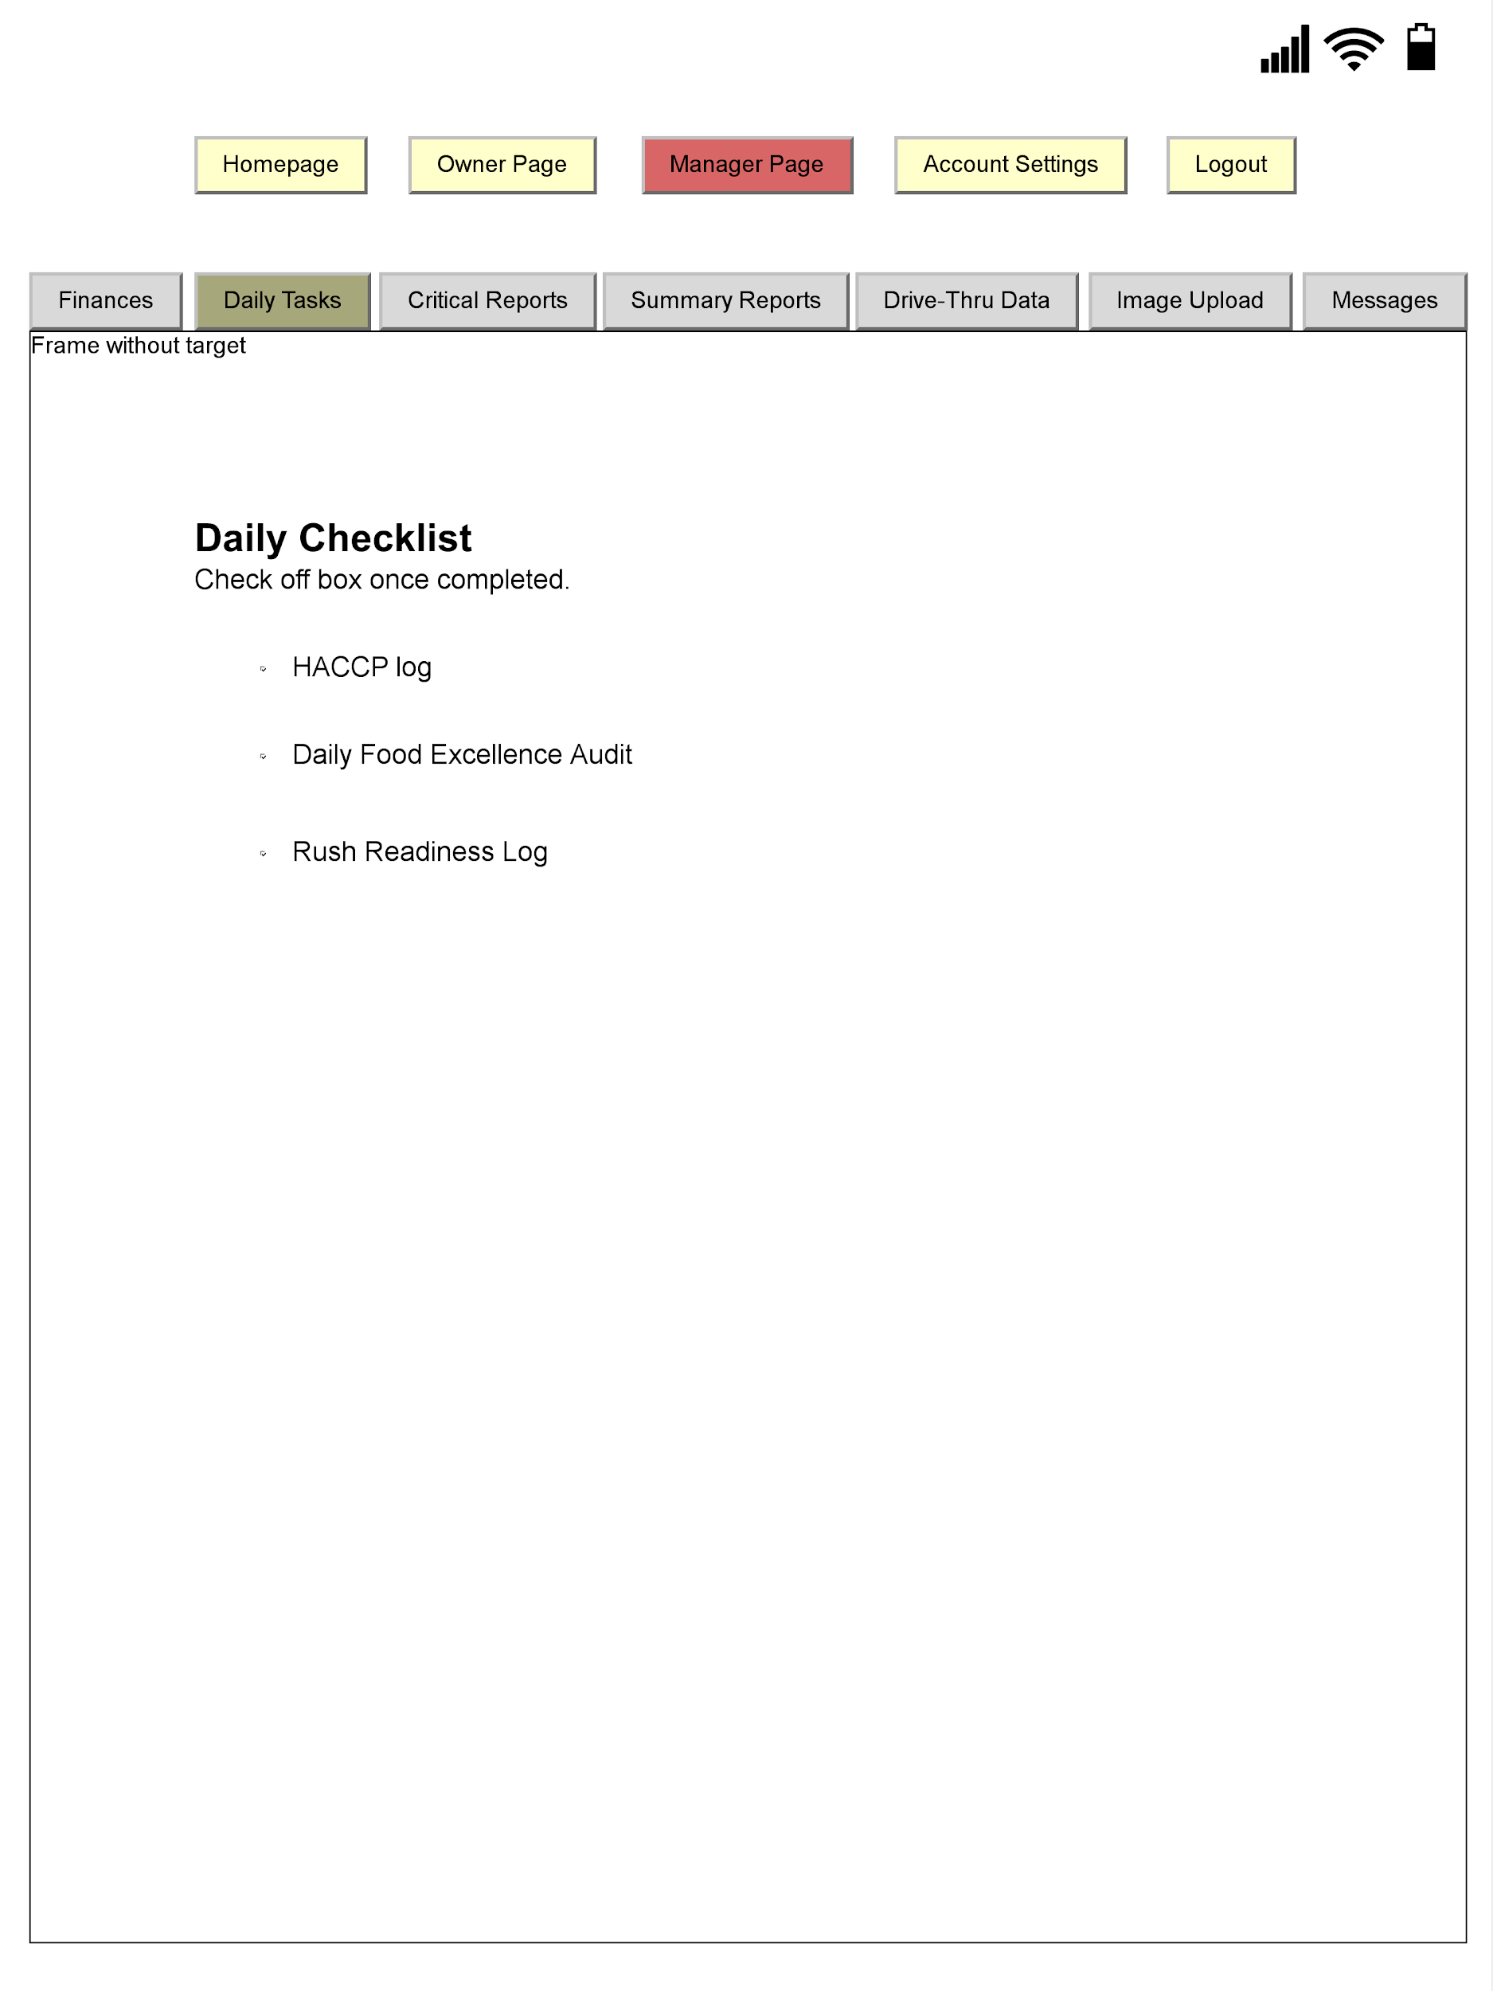

**Interface Standards**

The interface should allow users to create and mark off completed checklists. Each page is uniquely tailored to the type of user that is accessing the webpage. For instance, the owner is the only one that has access to create a new checklist. Additionally, the owner will be able to uniquely type in different tasks on the tab labeled “Create Checklist” while the manager will be able to mark off the tasks that has been completed on the “View Checklist” page. This allows both the manager and the owner to keep track of their duties. Additionally, once a manager completes a task, all tasks will be listed on a separate tab labeled “Daily Tasks”. The input of this webpage is how the owner is able to add a list of tasks for the manager to complete and how the manager is able to make adjustments to the list depending on which task was completed. The output is a separate list of tasks that will be created automatically by the system as shown on the “Daily Tasks” page. All information is stored on a cloud. Each page should be easy to navigate as all headers and links are uniform and consistent in placement, size, and shape. Furthermore, all users should be able to know which page they are currently on because the tabs at the top will be highlighted in red to stand out. Additionally, the page is very clean without a lot of clutter that would create confusion while navigating. The top of the screen is used as a navigation area, the content is located in the middle and the work area is located at the bottom. This is consistently shown throughout all pages. Colors and patterns were also chosen carefully in order to prevent any further confusion or inability to have certain objects on the page stand out when needed or necessary.

**Program Design**

Login Page:

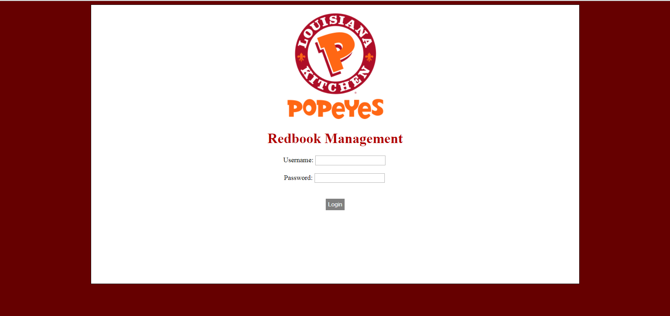

Create Checklist (Owner Page):

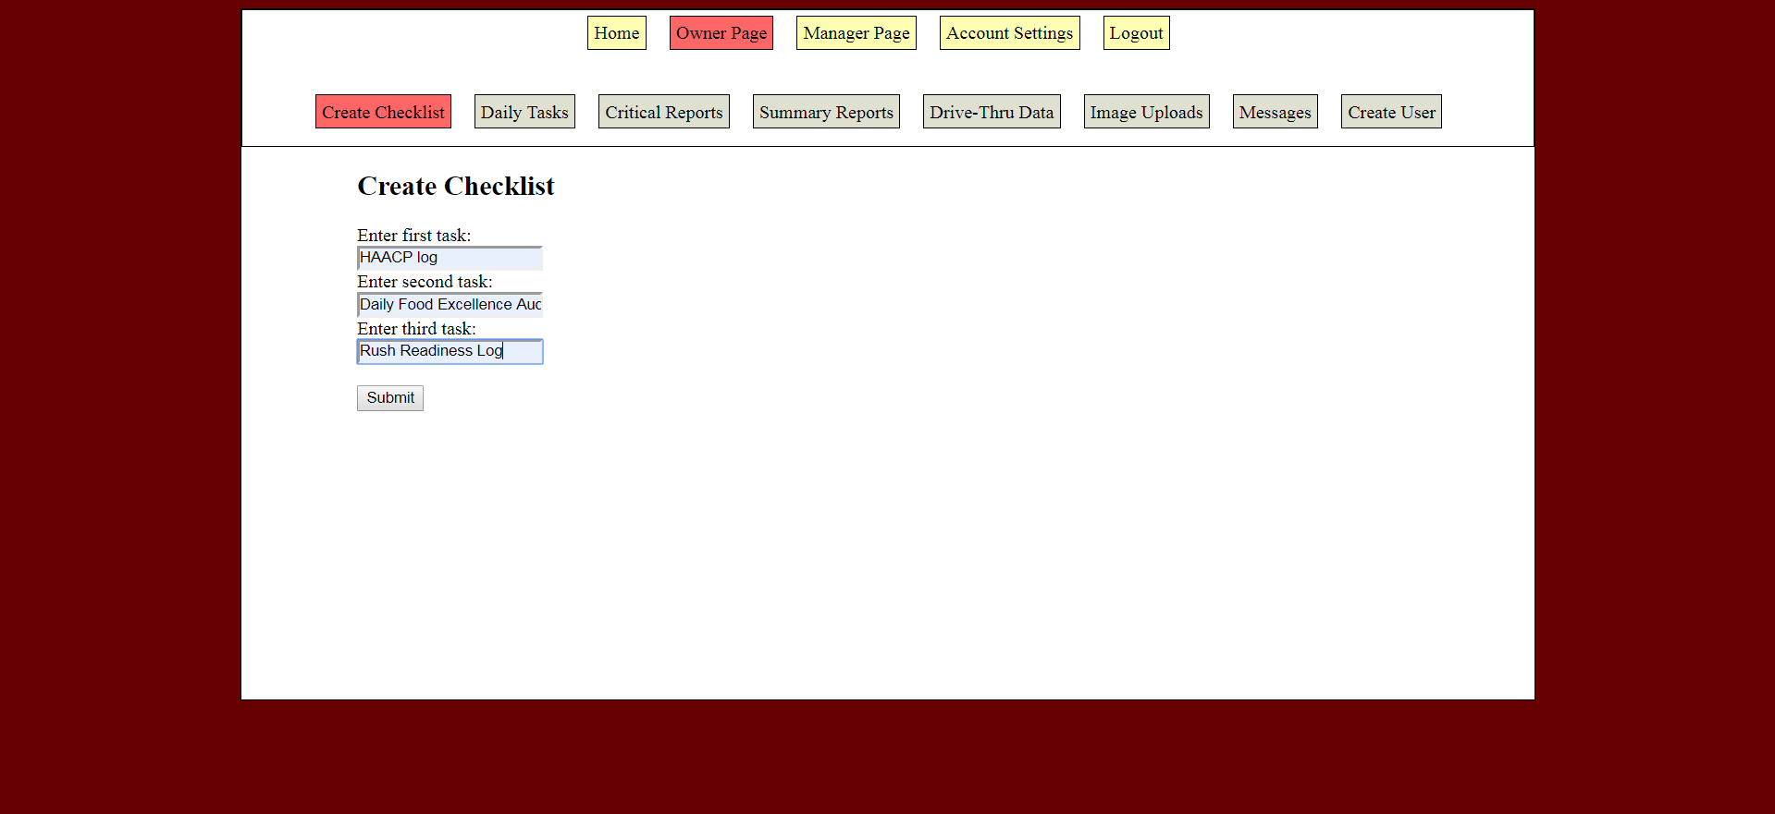

View Checklist (Manager Page):

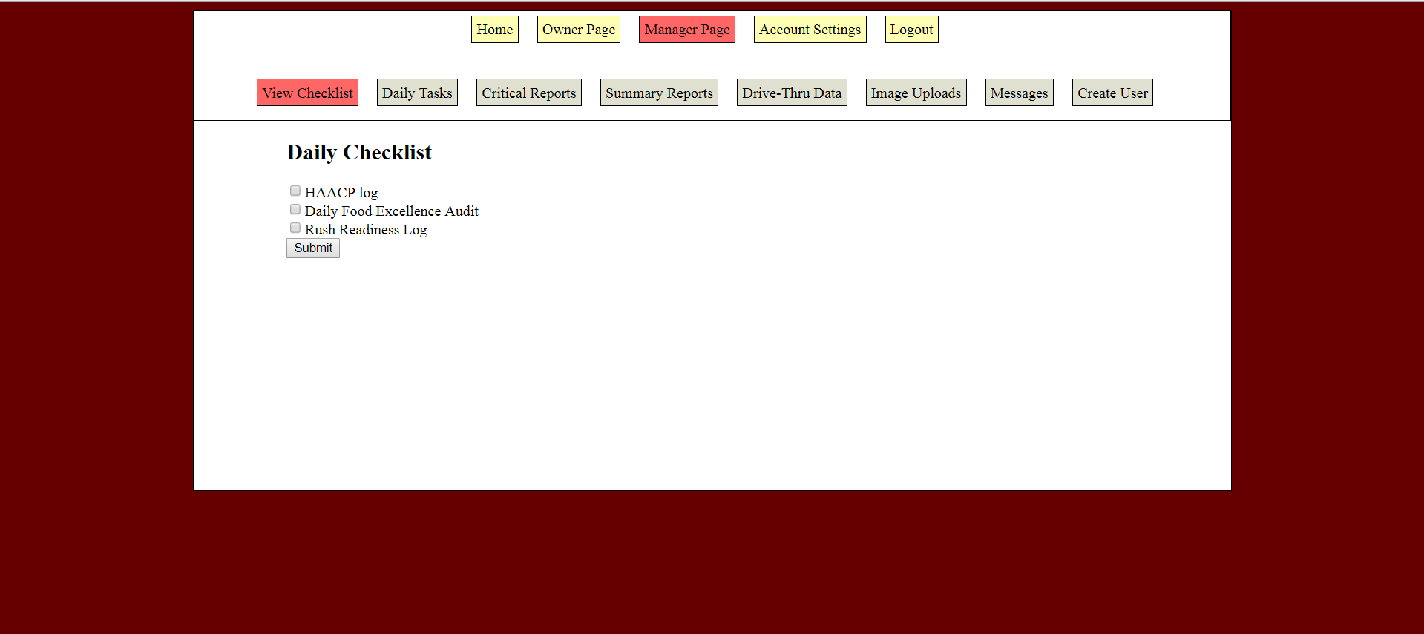

Daily Tasks Completed (Owner Page):

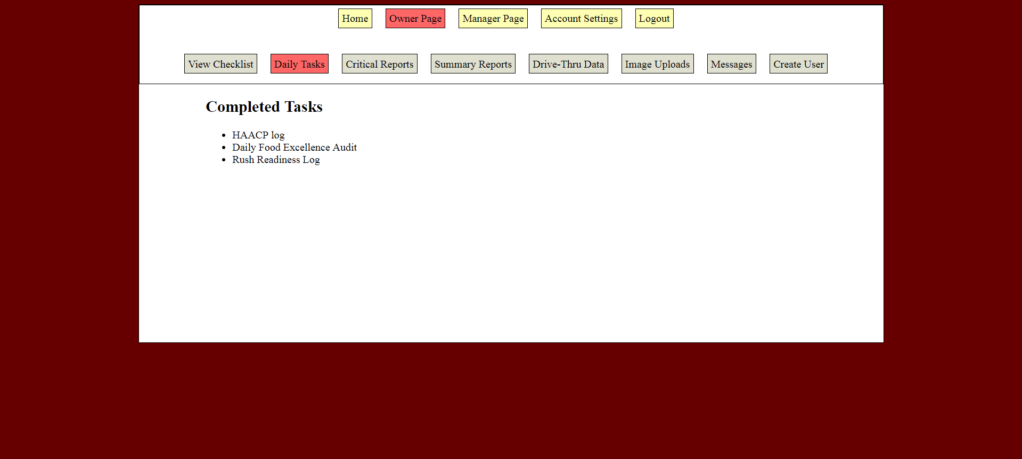

**System Requirements**

The main aim of this system requirement report is to establish how the stakeholders, managers, and other team members are integrated to head in one direction with a purpose of accomplishing the objectives of Popeyes restaurant. This systems requirement will include product documentation and process documentation. Product documentation, the product scope consists of the system and the end users analysis. This document highlights all the requirements of the system. Describes what the system should do depending on the business rules and the user story description. The roles and responsibilities of team members are defined including Popeye's owner, team members, and stakeholders. This app will enable Syed Abid Iqbal (owner) to evaluate the restaurant process and to make necessary improvements to the restaurant and to ensure that all the financial information is done under a single platform. Managers and the workers at popeyes restaurant can upload data, edit and share any information that is relevant in time. Furthermore, the system is designed in a way that it will allow the team members to manage the HACCP log that is necessary for the consciousness of the customers' health.

The system also allows the admin to make updates on employees’ information in real time and their contribution to the business. The team goal and the business goal are to provide food products in an effective manner considering the health of the customers and also make profits. The system requirements are set to explain the easiest way to which the application will help in bringing efficiency in Popeyes restaurant. The system requirements ensure quick data entry and also make user logins easy and reliable. The system requirement also provides the quality assurance of the app, the security measures and the design patterns of the system

**Team Experience**

In many aspects of life, one is often required to play a role as a team player. Different personalities affect the way they approach teamwork and related activities; some individuals prefer to take responsibility for their work and a particular form of doing things. Our team consists of eight members, and we were able to learn several aspects when working together on our project. Each member of our group was assigned various tasks, and this prevented a person from doing copious amounts of work: there was that team confidence that each member will accomplish his or her part of the task and in the needed time. The group had experience both on the project and as a team.

At first, we have actively engaged in the planning the management app which involved systems request and feasibility analysis for both the organization and the management app. The main aim of this part of our project was to study how the management can use this app to allow us to determine how the business conduct its activities so that we can come up with an app that meets the needs of the company. During the planning phase, we identified the need for a new management system that would achieve the objectives of the organization. Our group conducted a feasibility study and came up with a preliminary plan that provided solutions to particular situations. In the second, another experience was achieved through system analysis and requirements. In this stage, the major challenge experienced was identifying the precise functional requirements and needs of the end users. However, we resolved this problem by conducting a study to analyze the best system requirements and needs for the company that would use our app.

After identification of system requirements and needs, the team engaged in designing a system that consisted of specifications, features, and operations that will be compatible with the specific system requirements. At this stage, the major challenge experienced was the fact that we experienced some requirements that were not testable and in cases when they were testable the results indicated that they were not responsive to the proposed system design.

The team was also involved in the development of the management application system; this is where the real work began. The development of our app involved modeling the application system and making relevant changes for the app to perform its stated functions. Establishing a public profile was a challenge; there was a fear of doing it poorly which would be a significant wastage of time. However, we resolved this by understanding what was required for our management system to work correctly.

Process modeling and system requirement are among the critical part of our project that presented constant project related problems. Problem-solving is one of the best team experiences that were noted by all members by interacting with each other. The team members learned to be attentive to every detail in the projects; not only was it beneficial to the project but also the outside life of the team members. Every member of the group seemed to be moving in the same direction just fine. The members of our team were also able to acquire skills and the functions of working with different personalities, and each member realized how teamwork was an influential factor that contributes to team success

**Project Plan**

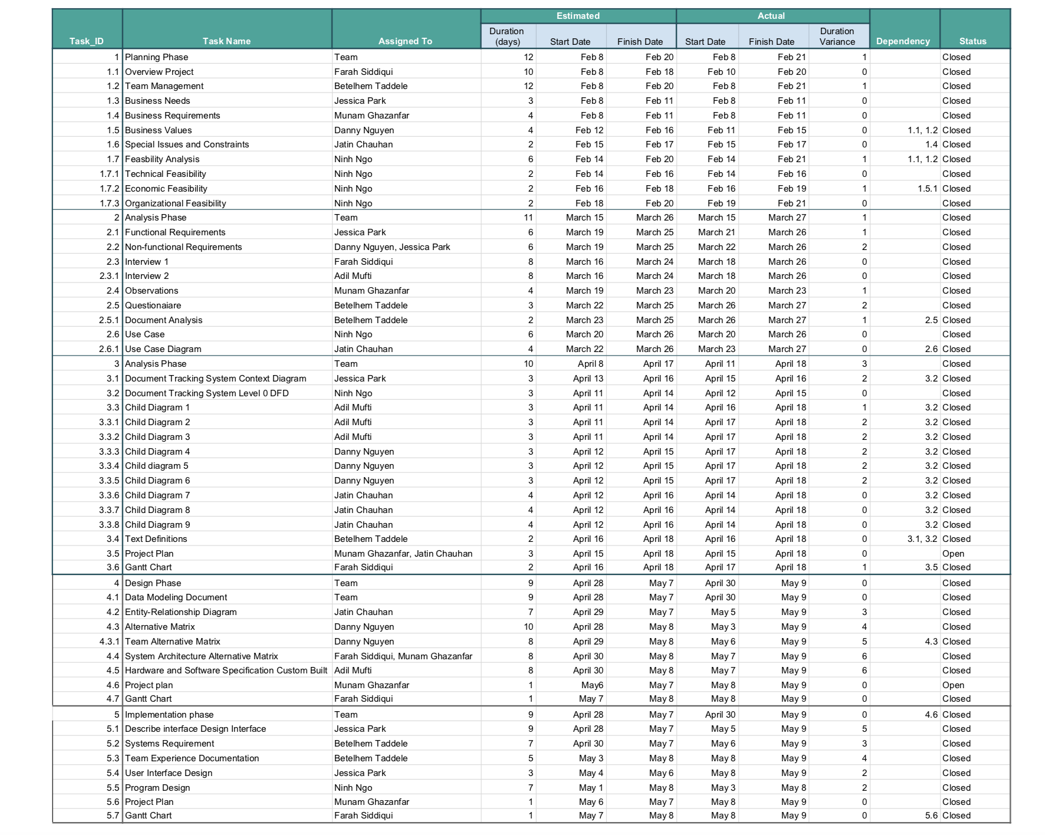

Gantt Chart

